**Requirement Gathering and Analysis Phase**

**Data Flow Diagram & User Stories**

|  |  |
| --- | --- |
| Date | 04-07-24 |
| Team ID | SWTID1719938064 |
| Project Name | ShopEZ: E-Commerce Application |
| Maximum Marks | 3 Marks |

**Data Flow Diagrams:**

A Data Flow Diagram (DFD) is a traditional visual representation of the information flows within a system. A neat and clear DFD can depict the right amount of the system requirement graphically. It shows how data enters and leaves the system, what changes the information, and where data is stored.

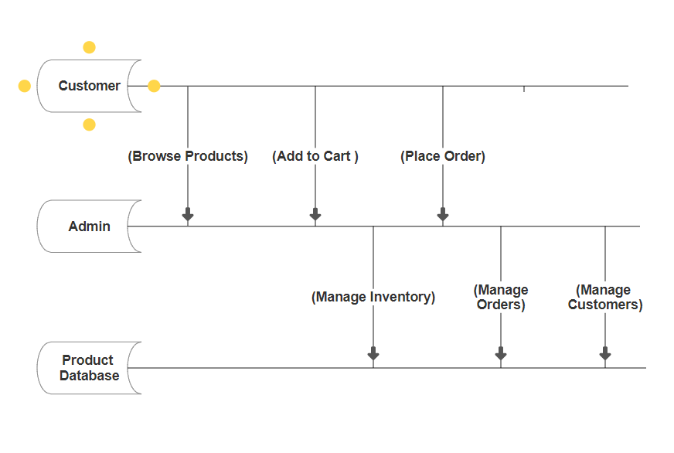

**User Stories**

| **User Type** | **Functional Requirement (Epic)** | **User Story Number** | **User Story / Task** | **Acceptance criteria** | **Priority** | **Release** |
| --- | --- | --- | --- | --- | --- | --- |
| Customer (Mobile user) | Registration | USN-1 | As a user, I can login for the application by entering my phone number, password. | I can access my account if password is correct | High | Sprint-1 |
|  |  | USN-2 | As a user, I will receive confirmation OTP once I have registered for the application | I can receive confirmation email & click confirm | High | Sprint-1 |
|  |  | USN-4 | As a user, I can register for the application through Gmail | I can register & access the dashboard with Gmail Login. | Medium | Sprint-1 |
| Customer (Web user) | Login | USN-5 | As a user, I can log into the application by entering email/number & password | I can access my account/dashboard. | High | Sprint-1 |
| Customer (Web user) | Dashboard | USN-6 | As a user, I can view and manage my orders from the dashboard of account. | I can see my order history and manage ongoing orders. | High | Sprint-2 |
| Customer Care Executive | Support | USN-7 | As a customer care executive, I can view and respond to customer queries. | any customer who is registered. | High | Sprint-1 |
| Administrator | User Management | USN-8 | As an admin, I can manage user accounts and authentications. | I can create, update, and delete user accounts. | High | Sprint-1 |
| Administrator | Analytics | USN-9 | As an admin, I can view and analyses what user is doing in application. | I can access user activity data and generate performance reports. | Medium | Sprint-2 |